ROHM Switching Regulator Solutions

Evaluation Board:

4.5V to 18V, 6A Integrated MOSFET

1ch Synchronous Buck DC/DC Converter

BD9C601EFJEVK-101 (3.3V | 6A Output)

No.000000000

* Introduction

This application note will provide the steps necessary to operate and evaluate ROHM’s synchronous buck DC/DC converter using the BD9C601EFJ evaluation boards. Component selection, board layout recommendations, operation procedures and application data is provided.

* Description

This evaluation board has been developed for ROHM’s synchronous buck DC/DC converter customers evaluating BD9C601EFJ. While accepting a wide power supply of 4.5-18V, an output of 3.3V can be produced. The IC has internal 50mΩ high-side Nch MOSFET and 35mΩ low-side Nch MOSFET and a synchronization frequency is of 500 kHz. A fixed Soft Start circuit prevents in-rush current during startup along with UVLO (Under Voltage Lockout Protection) and TSD (Thermal Shutdown Protection) circuits. An EN pin allows for simple ON/OFF control of the IC to reduce standby current consumption. Include OCP (Over Current Protection) and SCP (Short Circuit Protection).

* Applications

LCD TVs

Set Top Boxes (STB)

DVD/Blu-ray players/recorders

Broadband Network and Communication Interface

Entertainment Devices

* Evaluation Board Operating Limits and Absolute Maximum Ratings (TA=25oC)

|  |  |  |  |  |  |  |  |
| --- | --- | --- | --- | --- | --- | --- | --- |
| **Parameter** | | **Symbol** | **Limit** | | | **Unit** | **Conditions** |
| **MIN** | **TYP** | **MAX** |
| **Supply Voltage** | | | | | | | |
|  | BD9C601EFJ | V­CC | 4.5 | - | 18 | V |  |
| **Output Voltage / Current** | | | | | | | |
|  | BD9C601EFJ | VOUT | - | 3.3 | - | V |  |
| IOUT | - | - | 6 | A |  |

* Evaluation Board

Below is evaluation board with the BD9C601EFJ.

**Vout**

**GND**

**EN**

BD9673EFJ Eval Board

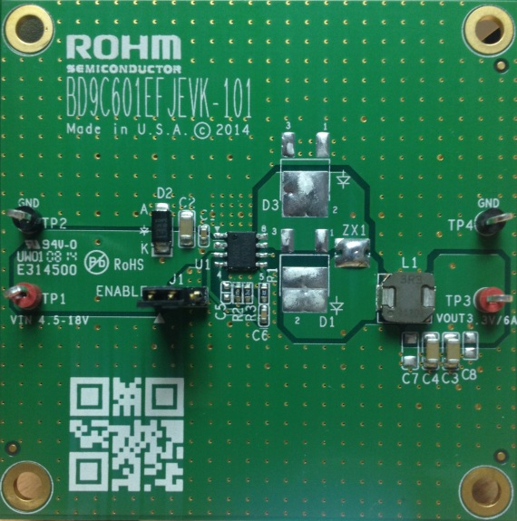

Fig 1: BD9C601EFJ Evaluation Board

* Evaluation Board Schematic

Below is evaluation board schematic for BD9C601EFJ.

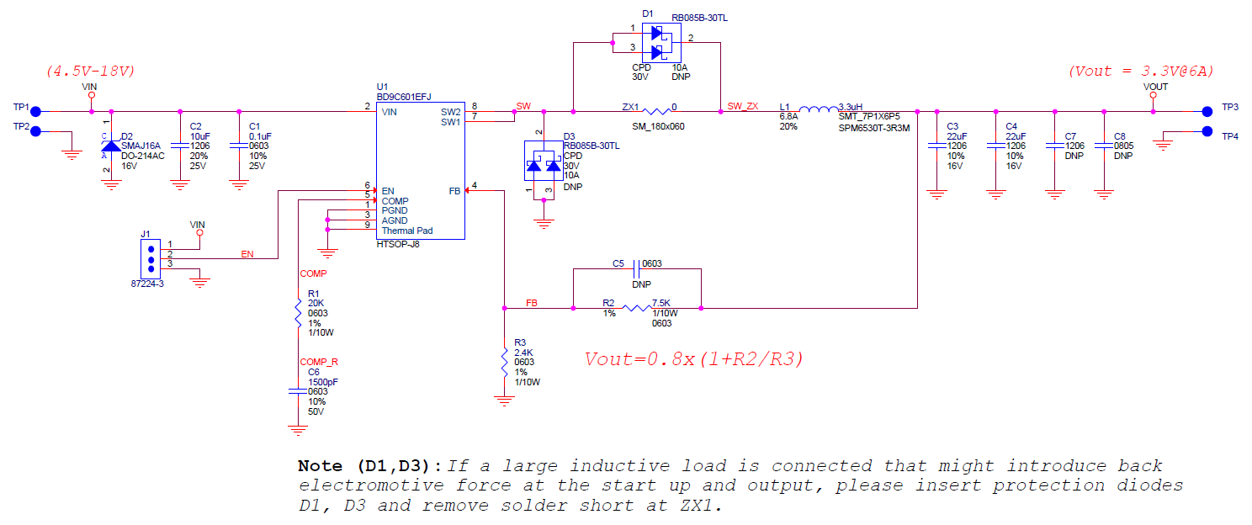

Fig 2: BD9C601EFJ Evaluation Board Schematic

* Evaluation Board I/O

Below is reference application circuit that shows the inputs (VIN, EN) and the output (VOUT).

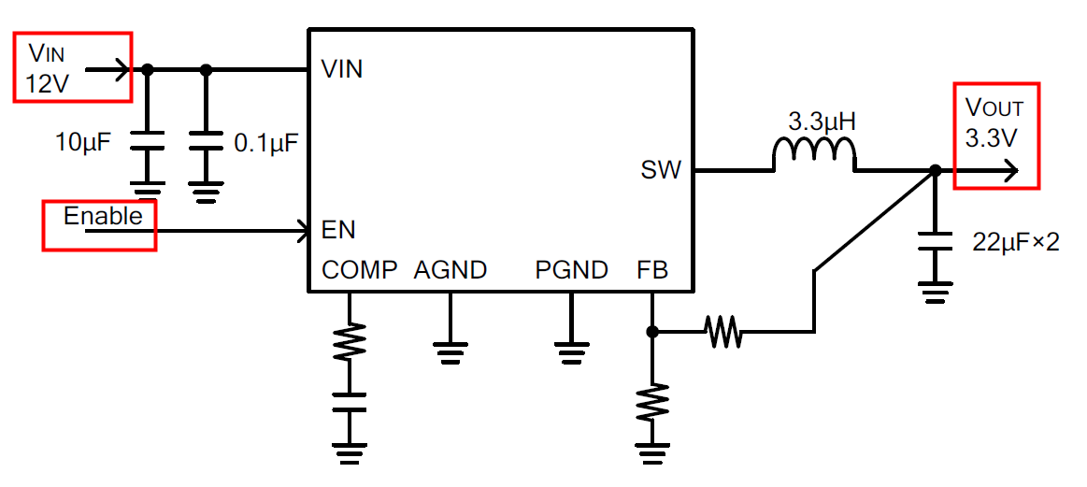

Fig 3: BD9C601EFJ Evaluation Board I/O

* Evaluation Board Operation Procedures

Below is the procedure to operate the evaluation board.

1. Connect power supply’s GND terminal to GND test point TP2 on the evaluation board.
2. Connect power supply’s VCC terminal to VIN test point TP1 on the evaluation board. This will provide VIN to the IC U1. Please note that the VCC should be in range of 4.5V to 18V.
3. Check if shunt jumper of J1 is at position ON (Pin2 connect to Pin1, EN pin of IC U1 is pulled high as default).
4. Now the output voltage VOUT (+3.3V) can be measured at the test point TP3 on the evaluation board with a load attached. The load can be increased up to 6A MAX.

Notes:

*Do not perform hot plugging on this board because the peak voltage transition could exceed the maximum voltage input rating 20V of BD9C601EFJ which may cause IC damage. Please refer figure 4*

* Reference Application Data for BD9C601EFJEVK-101

Following graphs show hot plugging test, quiescent current, efficiency, load response, output voltage ripple response of the BD9C601EFJ evaluation board.

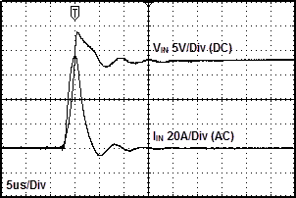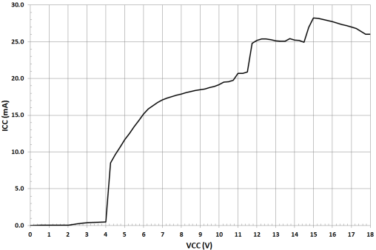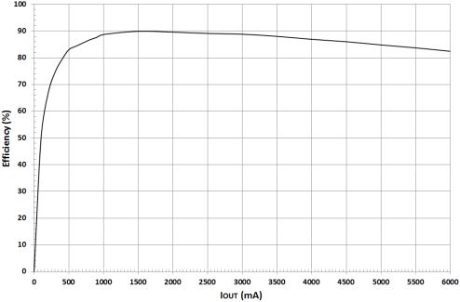

**Fig 4: Hot Plug-in Test with TVS Diode SMAJ16A, VIN=18V, VOUT=3.3V, IOUT=6A**

**Fig 5: Circuit Current vs. Power supply Voltage Characteristics (Temp=25oC)**

**Fig 6: Electric Power Conversion Rate**

**(VIN=12V, VOUT=3.3V)**

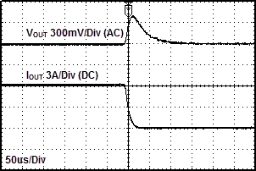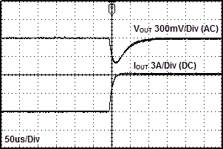

Fig 7: Load Response Characteristics

(VIN=12V, VOUT=3.3V, L=3.3uH, COUT=22uF[x2], IOUT=0A🡪6A)

Fig 8: Load Response Characteristics

(VIN=12V, VOUT=3.3V, L=3.3uH, COUT=22uF[x2], IOUT=6A🡪0A)

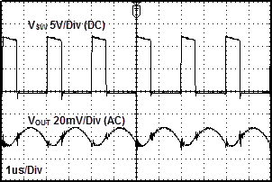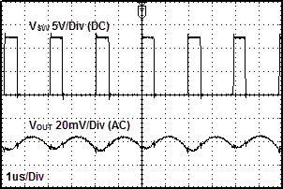

Fig 9: Output Voltage Ripple Response Characteristics

(VIN=12V, VOUT=3.3V, L=3.3uH, COUT=22uF[x2], IOUT=0A)

Fig 10: Output Voltage Ripple Response Characteristics

(VIN=12V, VOUT=3.3V, L=3.3uH, COUT=22uF[x2], IOUT=6A)

* Evaluation Board Layout Guidelines

In the step-down DC/DC converter, a large pulse current flows into two loops. The first loop is the one into which the current flows when the top FET is turned ON. The flow starts from the input capacitor CIN, runs through the FET, inductor L and output capacitor COUT and back to GND of CIN via GND of COUT. The second loop is the one into which the current flows when the bottom FET is turned on. The flow starts from the bottom FET, runs through the inductor L and output capacitor COUT and back to GND of the bottom FET via GND of COUT. Route these two loops as thick and as short as possible to allow noise to be reduced for improved efficiency. It is recommended to connect the input and output capacitors directly to the GND plane. The PCB layout has a great influence on the DC/DC converter in terms of all of the heat generation, noise and efficiency characteristics.

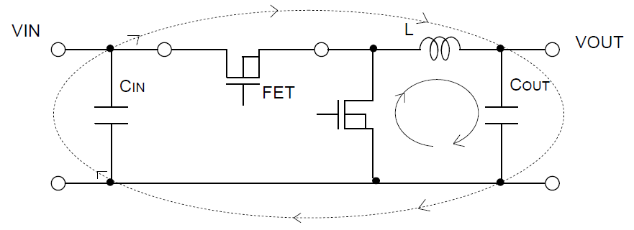

Fig 11: Current loop Buck regulator system

Accordingly, design the PCB layout considering the following points.

* Connect an input capacitor as close as possible to the IC VIN pin on the same plane as the IC.
* If there is any unused area on the PCB, provide a copper foil plane for the GND node to assist heat dissipation from the IC and the surrounding components.
* Switching nodes such as SW are susceptible to noise due to AC coupling with other nodes. Route the coil pattern as thick and as short as possible.
* Provide lines connected to FB and COMP far from the SW nodes.
* Place the output capacitor away from the input capacitor in order to avoid the effect of harmonic noise from the input.

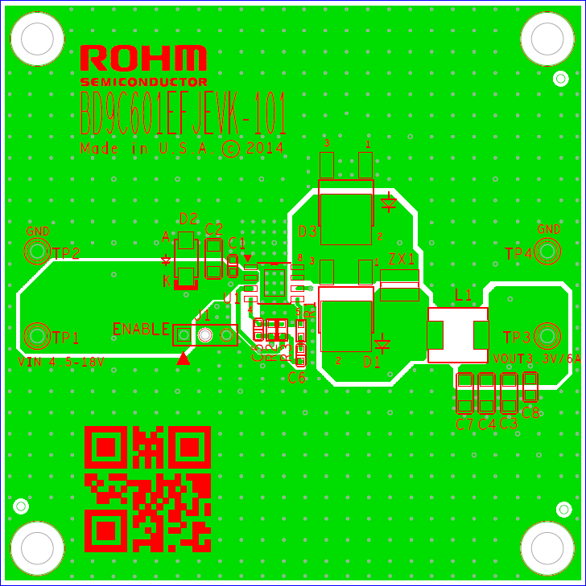

Fig 12: BD9C601EFJ Evaluation Board PCB Layout

* Calculation of Application Circuit Components

1. Output LC Filter Constant

The DC/DC converter requires an LC filter for smoothing the output voltage in order to supply a continuous current to the load. Selecting an inductor with a large inductance causes the ripple current ΔIL that flows into the inductor to be small. However, decreasing the ripple voltage generated in the output is not advantageous in terms of the load transient response characteristic. An inductor with a small inductance improves the transient response characteristic but causes the inductor ripple current to be large which increases the ripple voltage in the output voltage, showing a trade-off relationship. It is recommended to select an inductance such that the size of the ripple current component of the coil will be 20% to 40% of the average output current (average inductor current).

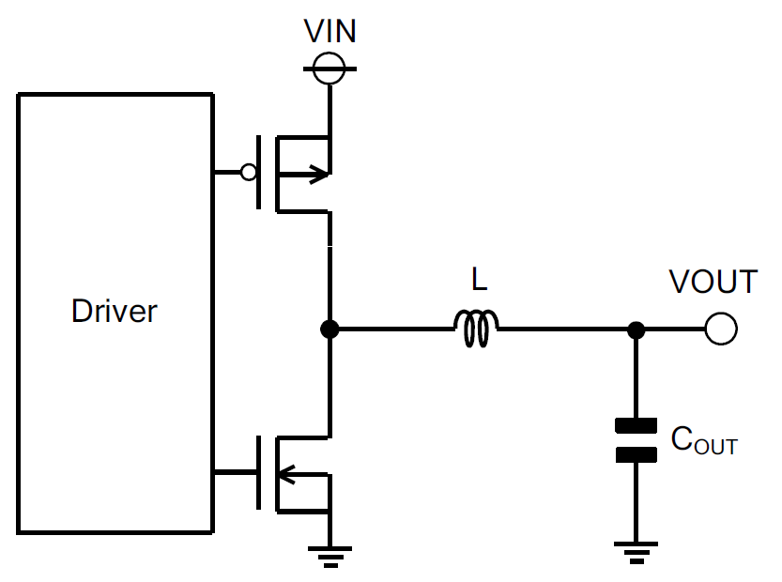

Fig 14: Output LC filter circuit

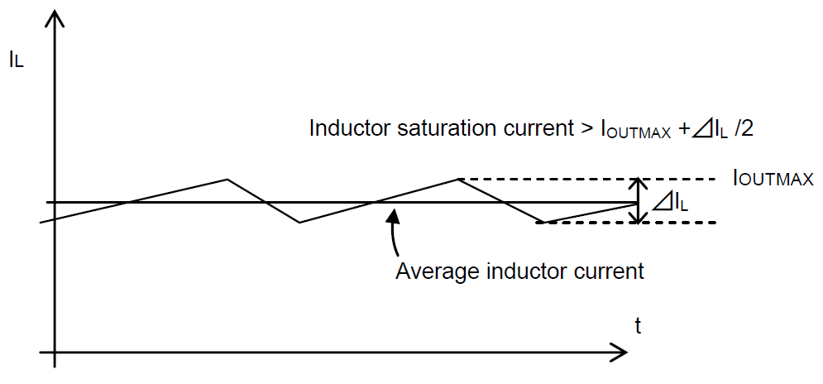

Fig 13: Waveform of current through inductor

With VIN = 12 V, VOUT = 3.3 V and the switching frequency FOSC = 500 kHz, the calculation is shown in the following equation.

Coil ripple current ∆IL = 30% x Average output current (5A) = 1.5 [A]

Where: FOSC is a switching frequency

The saturation current of the inductor must be larger than the sum of the maximum output current and 1/2 of the inductor ripple current ∆IL.

The output capacitor COUT affects the output ripple voltage characteristics. The output capacitor COUT must satisfy the required ripple voltage characteristics.

The output ripple voltage can be represented by the following equation.

Where: RESR is the Equivalent Series Resistance (ESR) of the output capacitor.

Also this IC provides 1msec [Typ.] soft start function to reduce sudden current which flows in output capacitor when startup. But when capacity value of output capacitor COUT becomes bigger than the following method, correct soft start waveform may not appear in some cases (Ex. VOUT over shoot at soft start).

Select output capacitor COUT fulfilling the following condition including scattering and margin.

Where:

IOCP is switch current restricted value (= 6.5A [min])

TSS is soft start time (= 0.5ms [min])

Caution: Concerning COUT total the capacity value of every part connected to Output line.

1. Output Voltage Setting

The output voltage value can be set by the feedback resistance ratio.

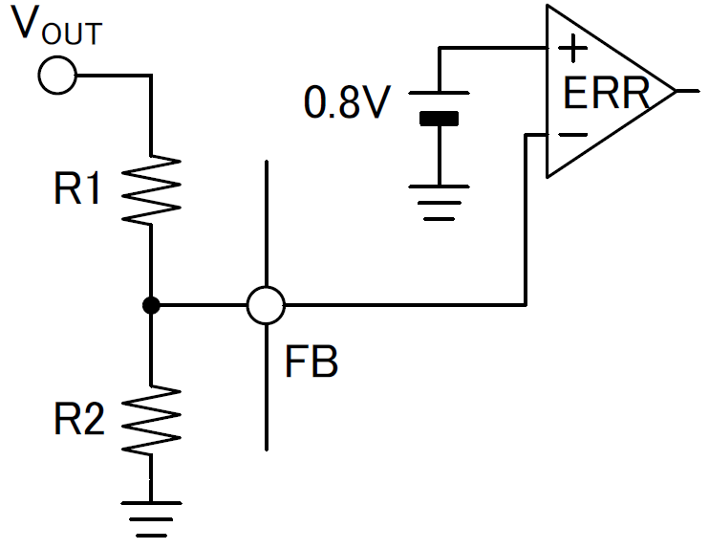

Fig15: Feedback Resistor Circuit

VOUT has restriction with VIN by the following equation

VOUTMin: 0.075 × VIN ≥ 0.8V

VOUTMax: 0.7 × VIN

1. Phase Compensation Component

A current mode control buck DC/DC converter is a two-pole, one-zero system. Two poles are formed by an error amplifier and load and the one zero point is added by phase compensation. The phase compensation resistor RCMP determines the crossover frequency FCRS where the total loop gain of the DC/DC converter is 0dB. A high value crossover frequency FCRS provides a good load transient response characteristic but inferior stability. Conversely, a low value crossover frequency FCRS greatly stabilizes the characteristics but the load transient response characteristic is impaired. Here, select the constant so that the crossover frequency FCRS will be 1/10 of the switching frequency.

1. Selection of Phase Compensation Resistor RCMP

The Phase Compensation Resistance RCMP can be determined by using the following equation.

VOUT is Output Voltage

FCRS is Crossover Frequency

COUT is Output Capacitance

VFB is Feedback Reference Voltage (0.8V Typ.)

GMP is Current Sense Gain (6.8A/V Typ.)

GMA is Error Amplifier Trans conductance (400μA/V Typ.)

1. Selection of Phase Compensation Capacitance CCMP

The phase compensation capacitance CCMP can be determined by using the following equation.

1. Loop Stability

To ensure the stability of the DC/DC converter, make sure that a sufficient phase margin is provided. A phase margin of at least 45º in the worst conditions is recommended.

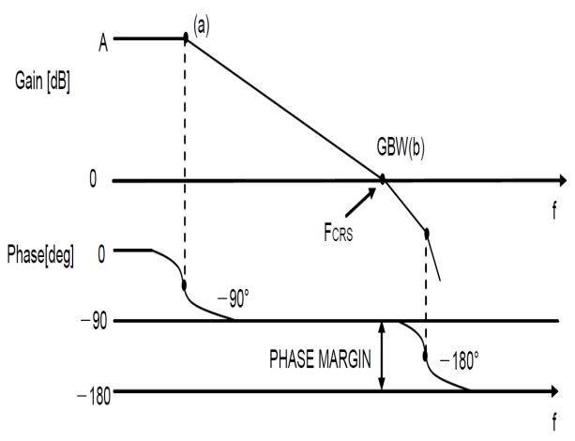

Fig 17: Bode Plot

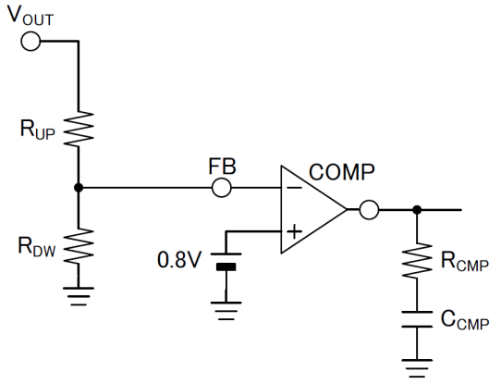

Fig 16: Phase Compensation Circuit

* Evaluation Board BOM

Below is a table with the build of materials. Part numbers and supplier references are provided.

|  |  |  |  |  |  |
| --- | --- | --- | --- | --- | --- |
| **Item** | **Qty.** | **Ref** | **Description** | **Manufacturer** | **Part Number** |
| 1 | 1 | C1 | CAP CER 0.1UF 25V 10% X7R 0603 | Murata | GRM188R71E104KA01D |
| 2 | 1 | C2 | CAP CER 10UF 25V 20% X5R 1206 | Murata | GRM31CR61E106MA12L |
| 3 | 2 | C3,C4 | CAP CER 22UF 16V 10% X5R 1206 | Murata | GRM31CR61C226KE15K |
| 4 | 1 | C6 | CAP CER 1500PF 50V 10% X7R 0603 | Murata | GRM188R71H152KA01D |
| 5 | 1 | D2 | TVS DIODE 16VWM 26VC SMA | Littelfuse Inc | SMAJ16A |
| 6 | 1 | J1 | CONN HEADER VERT .100 3POS 15AU | TE Connectivity Div | 87224-3 |
| 7 | 1 | L1 | INDUCTOR 3.3UH 6.8A 20% SMD | TDK Corporation | SPM6530T-3R3M |
| 8 | 1 | R1 | RES 20K OHM 1/10W 1% 0603 SMD | Rohm | TRR03EZPF2002 |
| 9 | 1 | R2 | RES 7.5K OHM 1/10W 1% 0603 SMD | Rohm | MCR03ERTF7501 |
| 10 | 1 | R3 | RES 2.4K OHM 1/10W 1% 0603 SMD | Rohm | MCR03ERTF2401 |
| 11 | 2 | TP1,TP3 | TEST POINT PC MULTI PURPOSE RED | Keystone Electronics | 5010 |
| 12 | 2 | TP2,TP4 | TEST POINT PC MULTI PURPOSE BLK | Keystone Electronics | 5011 |
| 13 | 1 | U1 | 4.5V to 18V Input, 6.0A Integrated MOSFET 1ch Synchronous Buck DC/DC Converter | ROHM | BD9C601EFJ |
| 14 | 1 | ZX1 | 1806 footprint solder-short during assembly |  |  |
| 15 | 1 |  | Shunt jumper for header J1 (item #6), CONN SHUNT 2POS GOLD W/HANDLE | TE Connectivity | 881545-1 |

**Notes**

No copying or reproduction of this document, in part or in whole, is permitted without the consent of ROHM Co.,Ltd.

The content specified herein is subject to change for improvement without notice.

The content specified herein is for the purpose of introducing ROHM's products (hereinafter "Products"). If you wish to use any such Product, please be sure to refer to the specifications, which can be obtained from ROHM upon request.

Examples of application circuits, circuit constants and any other information contained herein illustrate the standard usage and operations of the Products. The peripheral conditions must be taken into account when designing circuits for mass production.

Great care was taken in ensuring the accuracy of the information specified in this document. However, should you incur any damage arising from any inaccuracy or misprint of such information, ROHM shall bear no responsibility for such damage.

The technical information specified herein is intended only to show the typical functions of and examples of application circuits for the Products. ROHM does not grant you, explicitly or implicitly, any license to use or exercise intellectual property or other rights held by ROHM and other parties. ROHM shall bear no responsibility whatsoever for any dispute arising from the use of such technical information.

The Products specified in this document are intended to be used with general-use electronic equipment or devices (such as audio visual equipment, office-automation equipment, communication devices, electronic appliances and amusement devices).

The Products specified in this document are not designed to be radiation tolerant.

While ROHM always makes efforts to enhance the quality and reliability of its Products, a Product may fail or malfunction for a variety of reasons.

Please be sure to implement in your equipment using the Products safety measures to guard against the possibility of physical injury, fire or any other damage caused in the event of the failure of any Product, such as derating, redundancy, fire control and fail-safe designs. ROHM shall bear no responsibility whatsoever for your use of any Product outside of the prescribed scope or not in accordance with the instruction manual.

The Products are not designed or manufactured to be used with any equipment, device or system which requires an extremely high level of reliability the failure or malfunction of which may result in a direct threat to human life or create a risk of human injury (such as a medical instrument, transportation equipment, aerospace machinery, nuclear-reactor controller, fuel-controller or other safety device). ROHM shall bear no responsibility in any way for use of any of the Products for the above special purposes. If a Product is intended to be used for any such special purpose, please contact a ROHM sales representative before purchasing.

If you intend to export or ship overseas any Product or technology specified herein that may be controlled under the Foreign Exchange and the Foreign Trade Law, you will be required to obtain a license or permit under the Law.



Thank you for your accessing to ROHM product information.

More detail product information and catalogs are available, please contact us.

**ROHM Customer Support System**

<http://www.rohm.com/contact/>